

**I DIRITTI NON SONO   
MAI FUORI STAGIONE**

**RIGHTS ARE NEVER   
OUT OF SEASON**

***#Rights4AllSeasons***

**National labour Inspectorate**

**Guarantor of the legality of the job**

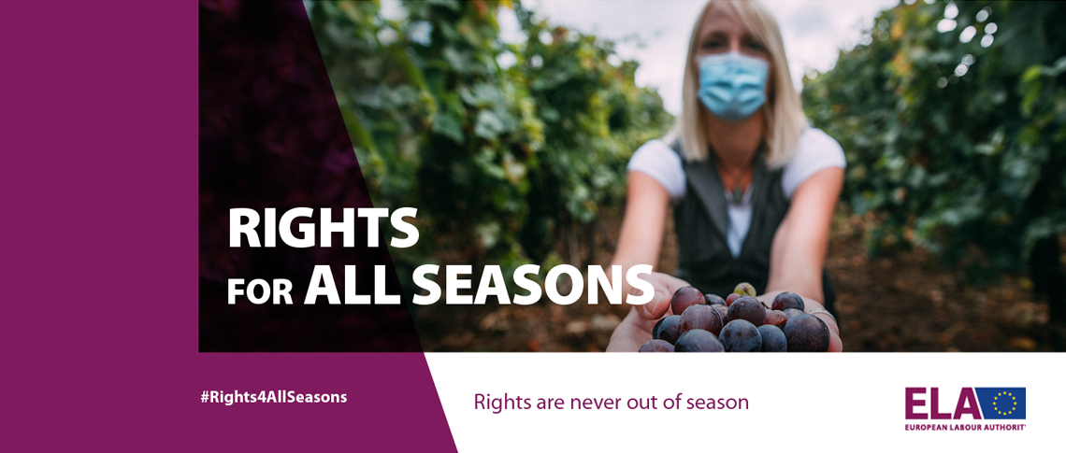

***#Rights4AllSeasons***

***Week of Action 20-24 September 2021***

***www.ispettorato.gov.it***



**North- East interregional labour inspectorate**

Calle Nova de San Simeon, n. 706  
30135 Venezia

**All services are also provided online or by appointment**

For information or to ask for our intervention:

*IIL.Venezia@ispettorato.gov.it*

ph. 041 301781

***www.ispettorato.gov.it***

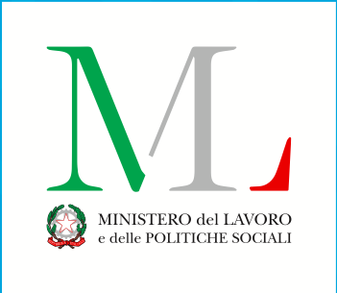



***Request for information on workwers’ right***

***Complints and request for inspection***

***Findings for payment of***

***Remuneration***

***Attempts at conciliation***

***to resolve labour disputes***

***Implementing provisions to eliminate other irregulalarities* Seasonal foreign workers have the same rights.*You can contact the inspectorate for:***

***The National Labour Inspectorate supervises and provides important service to ensure legality in the world of work.***

***It is the institution to which workers and companies can turn for the protection of rights and legality at work.***

***It is the reference point for the correct information, interpretation and application of labour and social insurance legislation (INPS, INAIL...)***

***Eve and coordination of other labour supervisory bodies. It coordinates with the ASL on occupational safety.***

***Authorisations of the protection of working mothers and minors***

***Authorisations to recruit foreign workers***

***Assistance to formalize telematic resignation***

***Validation of resignation in the first year of marriage or with children up to 3 years***

***authorisations and ratings***

***for the protection of employment (steam boilers, remote controls)***