

**I DIRITTI NON SONO   
MAI FUORI STAGIONE**

**RIGHTS ARE NEVER   
OUT OF SEASON**

***#Rights4AllSeasons***

**National Labour Inspectorate**

**Guarantor of the legality of the job**

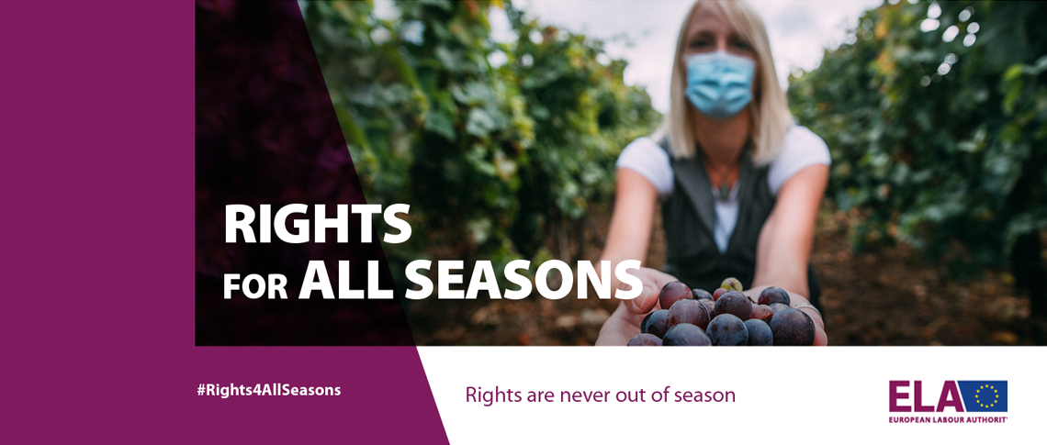

***#Rights4AllSeasons***

***Week of Action 20-24 September 2021***

***www.ispettorato.gov.it***



**Labour Inspectorate**

**Ferrara-Rovigo**

Via Giuseppe Garibaldi, 147/151 - Ferrara

Via Generale D. Piva, 25/27 - Rovigo

**All services are also provided online or by appointment**

For information or to ask for our intervention:

[itl.ferrara-rovigo@ispettorato.gov.it](mailto:ITL.Ferrara-Rovigo@ispettorato.gov.it)

ph. **0532/410711 Ferrara**

**0425/154841 Rovigo**

***www.ispettorato.gov.it***

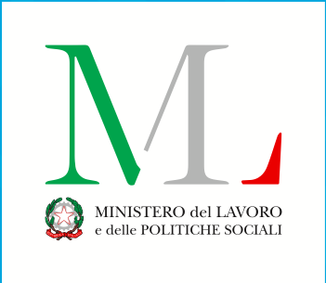



***Request for information on workwers’ right***

***Complints and request for inspection***

***Findings for payment of***

***Remuneration***

***Attempts at conciliation***

***to resolve labour disputes***

***Implementing provisions to eliminate other irregulalarities* Seasonal foreign workers have the same rights.*You can contact the inspectorate for:***

***The National Labour Inspectorate supervises and provides important service to ensure legality in the world of work.***

***It is the institution to which workers and companies can turn for the protection of rights and legality at work.***

***It is the reference point for the correct information, interpretation and application of labour and social insurance legislation (INPS, INAIL...)***

***Eve and coordination of other labour supervisory bodies. It coordinates with the ASL on occupational safety.***

***Authorisations of the protection of working mothers and minors***

***Authorisations to recruit foreign workers***

***Assistance to formalize telematic resignation***

***Validation of resignation in the first year of marriage or with children up to 3 years***

***authorisations and ratings***

***for the protection of employment (steam boilers, remote controls)***